What is Array?

- An Array is a collection of items stored at contiguous memory locations.
- The idea is to store multiple items of the same type together.
- Each element can be uniquely identified by their index in the array.
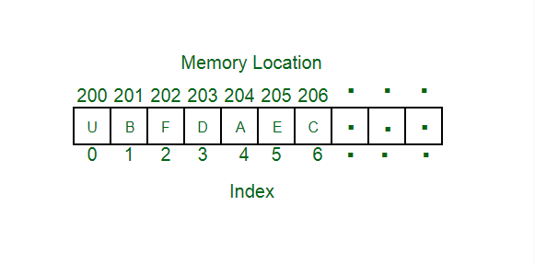
Why do we need arrays?

- We can use normal variables (v1,v2,v3, ..) when we have a small number of objects, but if we want to store a large number of instances, it becomes difficult to manage them with normal varaiable.
- The idea of an array is to represent many instances in one variable.

Advantage of an Array:

- Random access of elements using array index.
- Traversal through the array becomes easy using a single loop.

Disadvantages of an Array:
- Allows a fixed number of elements to be entered, which is decided at the time of declaration.
- Insertion and deletion of elements can be costly since the elements are needed to be managed in accordance with the new memory allocation in C / C++.

Vector in C++:

- A vector in C++ is a class in STL that represents an array.
- We do not need to pass size as an extra parameter when we declare a vector. Vector supports dynamic sizes. We can also resize a vector.
- Vectors have many in-built function like, removing an element etc.

